Technical Information

Technical Consultation for Reactor Containment Building
HVAC System of Sodium-cooled Fast Reactor

2015.08



TABLE OF CONTENTS

CHAPTER Ⅰ - GENERAL INFORMATION
1. OBJECTIVES
2. PROJECT DESCRIPTION

CHAPTER Ⅱ - TECHNICAL INFORMATION
1. SCOPE OF THE WORK
2. METHODS OF PERFORMANCE
3. CONSULTING SCHEDULE
4. DELIVERABLE
5. BUDGET

CHAPTER Ⅰ

GENERAL INFORMATION

- OBJECTIVES

- PROJECT DESCRIPTION
1. OBJECTIVES

The objective of this consulting service is to technical information for the containment building HVAC System which is based on the requirement of the prototype Sodium-cooled Fast Reactor.

2. PROJECT DESCRIPTION
KEPCO E&C is developing the design of Balance Of Plant (BOP) system of the prototype Sodium-cooled Fast Reactor (SFR).

KEPCO E&C (hereinafter referred to as ‘KEPCO’) does not have any experience on the SFR requirements application to the containment building HVAC System in the nuclear power plant projects. Therefore, KEPCO plans to design reactor containment building HVAC system with the technical support from consulting company which has sufficient capabilities and experiences in the fields related to the issues dealt with in this technical specification.

The scope of the work activities is specified in the Section 2 of this document and the corresponding Work Package (WP) is as follows:

- (WP) Consulting for the containment building HVAC system

The Contractor who has sufficient capabilities and experiences on the above WP is required to provide technical consulting services presented in Section 2 of this document.

It is required for the Contractor to prepare a proposal which contains the followings:

- Contractor’s qualifications, experience and capabilities in the proposed work package(s)
- Details of the work performance methods to accomplish the goal of the work packages(s)
- Identification of the responsible staffs and organization to perform the work activities
- Pricing information of the services

The proposals submitted by the potential contractors will be reviewed and evaluated by KEPCO staffs and the final contractor will be determined for the work package based on the evaluation.

CHAPTER Ⅱ

TECHNICAL INFORMATION

- SCOPE OF SERVICES

- METHODS OF PERFORMANCE

- CONSULTING SCHEDULE

- DELIVERABLE

- BUDGET

- SCOPE OF SERVICES

To achieve the above goals, the Contractor shall provide the following engineering services to KEPCO.

The Reactor Containment HVAC system is required to maintain suitable temperature, pressure and radiation condition in the reactor building. The below figure is the schematic general arrangement drawing of reactor building. The reactor building served by reactor building HVAC system is divided into three areas which are dome area (tinted Yellow), head access area (tined Blue), and other areas (tinted Green). The dome area is an operating floor and laydown area and crane are located in this area. Also, the dome area is connected to personnel airlock, equipment hatch. The cold leg/ hot leg piping, Control Rod Drive Mechanism (CRDM), rotating plug, In-Vessel Transfer Machine (IVTM) and others are located in the head access area (HAA). Other areas are related to sodium and expansion tanks of Sodium-Water Reaction Pressure Relief System are located in these areas.

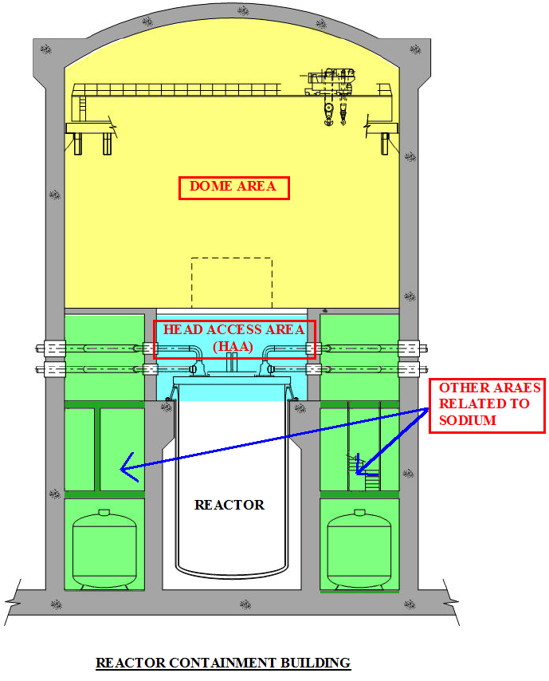

- Task 1 (Kick-off meeting)
KEPCO and the Contractor will have a kick-off meeting. KEPCO staffs will visit Contractor’s office for the meeting. Activities that will be done during the meeting are as follows:

  - Both KEPCO and Contractor discuss details on how to perform the consulting services.

Details of the meeting agenda will be confirmed after the contract is signed.

- Task 2 (Design for Reactor Containment HVAC system)

The Contractor performs the following work activities to provide following deliverables:

(2.1) Design Concept

- Providing design requirements of reactor building HVAC system of the SFR based on Codes & Standards
- Providing design guide to determine safety classification and seismic category of HVAC equipment (such as AHU, ACU, unit cooler, dampers and ductworks) as in the reactor building HVAC system of the SFR
- Providing air flow rate calculation method (such as required air change rate per hour or maintaining design pressure during normal and accident condition

(2.2) System Configuration

- Recommending conceptual diagram of the reactor building HVAC system for SFR based on schematic general arrangement drawing of reactor building

(2.3) Interface System Requirements

- Providing other interface system requirements, such as fire protection, Inert gas receiving and processing system (Argon/Nitrogen distribution system)

- Providing the method of prevention of sodium-water interaction in the duct, chilled water piping, HVAC equipment and etc
- HVAC equipment installation criteria for the room applied for sodium fire protection

- Task 3 (Review and Preparation of Final Documents)
Contractor provides the electronic files to KEPCO when the Contractor completes Task 2. KEPCO will review the outcomes and send comments and/or questions, if any. The Contractor prepares final drawings and documents containing the outcomes performed in the work activities from Task 2 and Task 3.

2. METHODS OF PERFORMANCE

- KEPCO E&C
- Provides design information so that the Contractor can perform the tasks.
- Reviews the reports prepared by the Contractor

- Consulting company
- Provides the consulting services that are defined in Task 1 through Task3.
- Provides the deliverables to KEPCO as defined in Section 4.

3. Consulting Schedule

Duration of the WP is 3 months after the contract is signed.

Details of the time schedule for each work activity shall be presented in the Contractor’s proposal.

Activity | DOR | Month/Week after Contract
Activity | DOR | 1st month |  |  |  | 2nd month |  |  |  | 3rd month
Activity | DOR | 1 | 2 | 3 | 4 | 5 | 6 | 7 | 8 | 9 | 10 | 11 | 12
Contract Awards | Both
Task 1. Kick-off Meeting | Both
Task 2. Primary documents | CC
Review of the primary documents | KEPCO
Task 3. Preparation of final documents | CC

- DELIVERABLE

- Drawings and report presenting contents of the Task 2 and 3
- Presentation materials in the meetings

Details of the schedule for the deliverables shall be presented in the Contractor’s proposal.

- Budget

The project is fixed fee. Payments will be provided as indicated elsewhere in the contract, and no detailed accounting of project expenditures are required by KEPCO ENC.

